1.2.2
a.
Principle Component Analysis can be used to reduce the dimensions of a (large) dataset. It is also used to indicate the variance in a dataset (standard deviation).

b.
Both EVD and SVD split up the initial matrix in three values. M = U, S, V^{T} for SVD and
M = Q, Λ and Q⁻¹ for EVD.
For both EVD and SVD it is true that the left-singular vectors (U or Q) are eigenvectors of M*M^{T}.
Another similarity is that for both EVD and SVD it is true that the right-singular vectors (V^{T} or Q⁻¹) are eigenvectors of M^{T}*M.

c.
first pc variance = 76.35 %
second pc variance = 11.50 %
third pc variance = 4.90 %
sum of first three variance = 92.75 %

d.
The benefits of plotting the PCA projections is that most of the data variance is shown in the plot. When plotting only two original dimensions, the other data is not taken into account.

e.
Second PC direction : [ 0.35153606 -0.06817937 0.16197185 0.16124192 -0.749146 -0.37473452 -0.31953982 -0.1256533 ]
This means that the second principal component mainly captures the variation of the 5th attribute (-0.75). Other attributes that contribute to more to the second principal component are the 1st, 6th, and 7th attributes with variances of 0.35, -0.37 and -0.32.
The cause of an attribute having a large projection into a principal component is that the spread in the values of this attribute is higher than that of other attributes.

1.3.1
The most similar measures seem to be 'Cosine' and 'Correlation'. 'SMD' produced results which were the least comparable to the other measures (and in my opinion the least correct results).
The reason why I think SMD is the worst similarity measures is that it can still give a high score even if two images are not very similar, i.e.: when two images have the same values at 50% of the positions, the similarity score is 0.5, where other similarity measures give a higher or lower score, depending on the overall similarity, and not that if single pixels.
The best results were produced by the Cosine measure.

1.3.2
Cosine + scaling : Correct
ExtendedJaccard + scaling : Not correct
Correlation + scaling : Corrent
Cosine + translation : Not correct
ExtendedJaccard + translation : Not correct
Correlation + translation : Correct

See code for reference.

1.2.1 b.
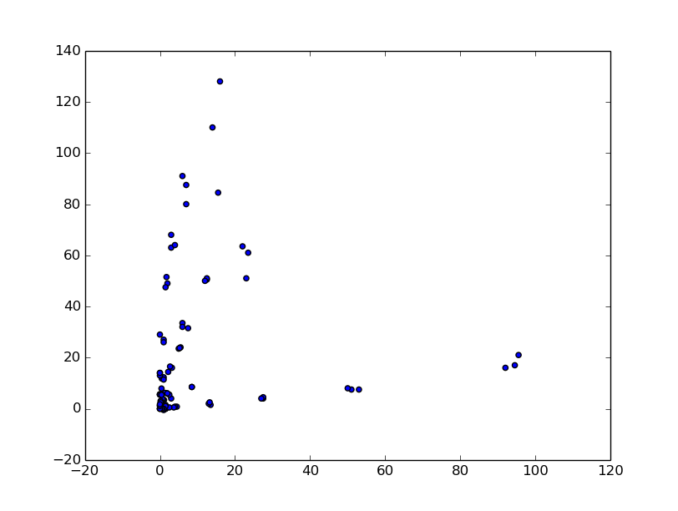
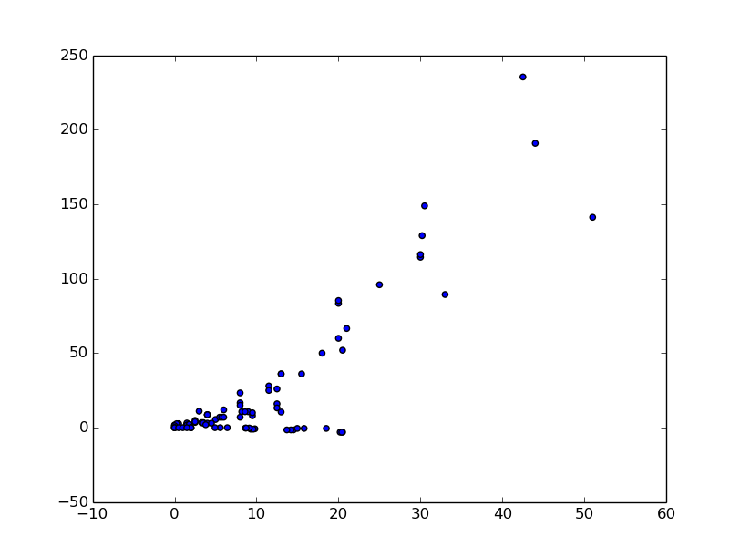
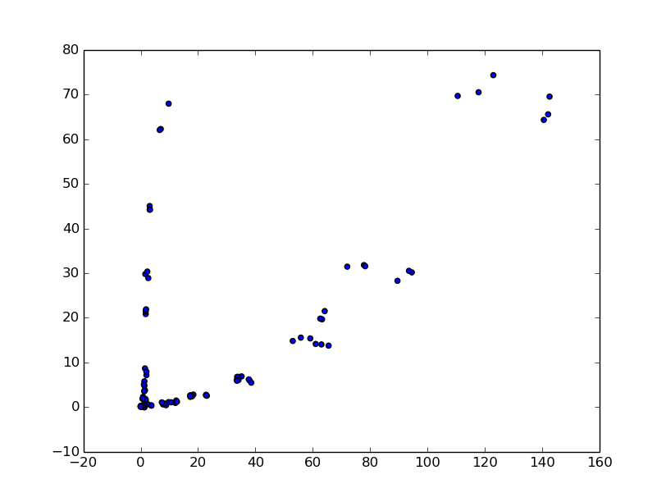

Attribute A (x-axis) vs attribute B (y-axis) Attribute C (x-axis) vs attribute D (y-axis)
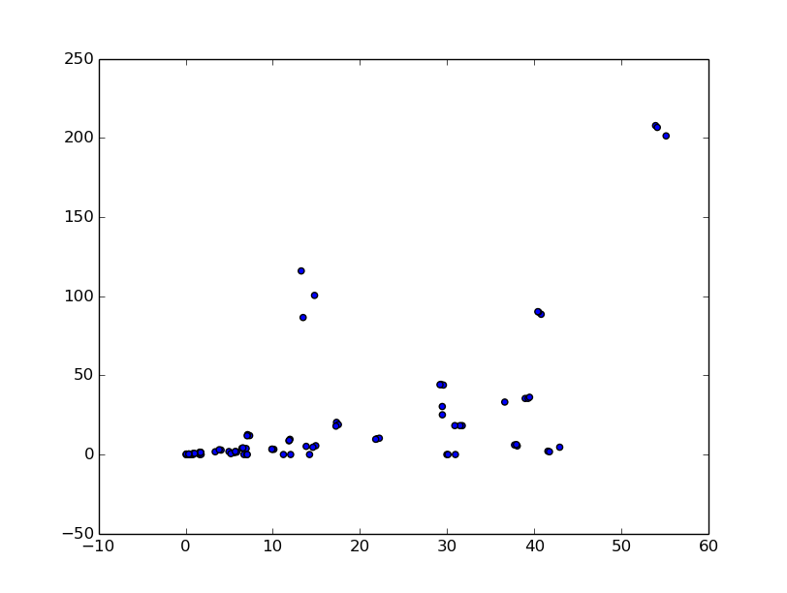

Attribute E (x-axis) vs attribute F (y-axis) Attribute G (x-axis) vs attribute H (y-axis)

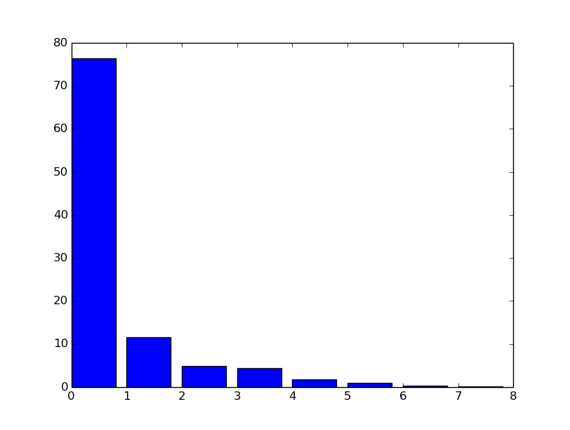
1.2.2 c.

Percentage of variance by each principal component

1.2.2 d.
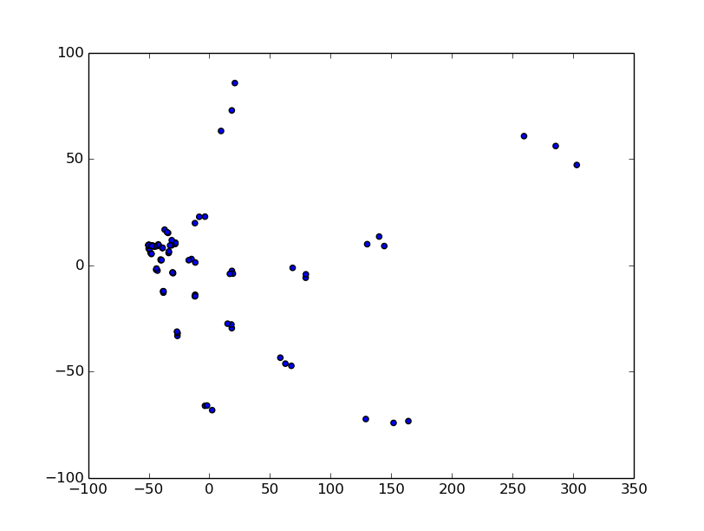

First PCA projection (x-axis) vs Second PCA projection (y-axis)

